# Project 5: Audio Compression

Sophaktra Suy

**Problem 1**

Changing the bits to 4, window size n to 32, and frequency to 436 Hz gave an RMSE of 0.0086.

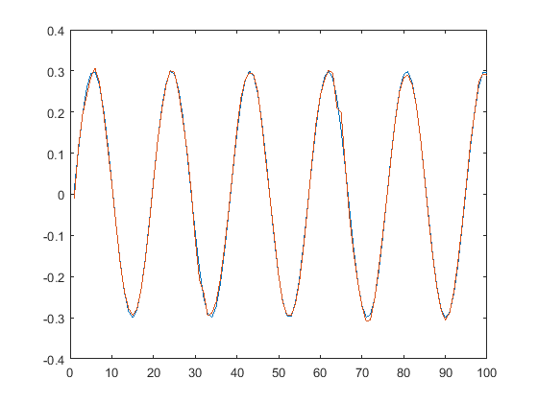

**Problem 2**

RMSE for 4 bits: 0.0086

RMSE for 5 bits: 0.0040

RMSE for 6 bits: 0.0020

RMSE for 7 bits: 0.000957

RMSE for 8 bits: 0.000483

**Problem 3**

RMSE: 0.0049

**Problem 4**

**Problem 5**

Without windowing

RMSE for 2 bits: 0.0216

RMSE for 4 bits: 0.0069

RMSE for 6 bits: 0.0019

RMSE for 8 bits: 0.000479

With windowing

RMSE for 2 bits: 0.0141

RMSE for 4 bits: 0.0041

RSME for 6 bits: 0.0012

RMSE for 8 bits: 0.000365